Sociology Notes
Sociology – a Down to Earth Approach by James M. Henslin

Collective Behavior
-actions by a group of people who bypass the usual norms and do something unusual

How the Crowd Transforms the Individual
-people feel anonymous in crowds
-less acountable for thier actions
-invincibility
-people agree to almost any suggestion
-this behavior/mindset is contagous

The Acting Crowd
-an acting crowd is an excited group that moves toward a goal
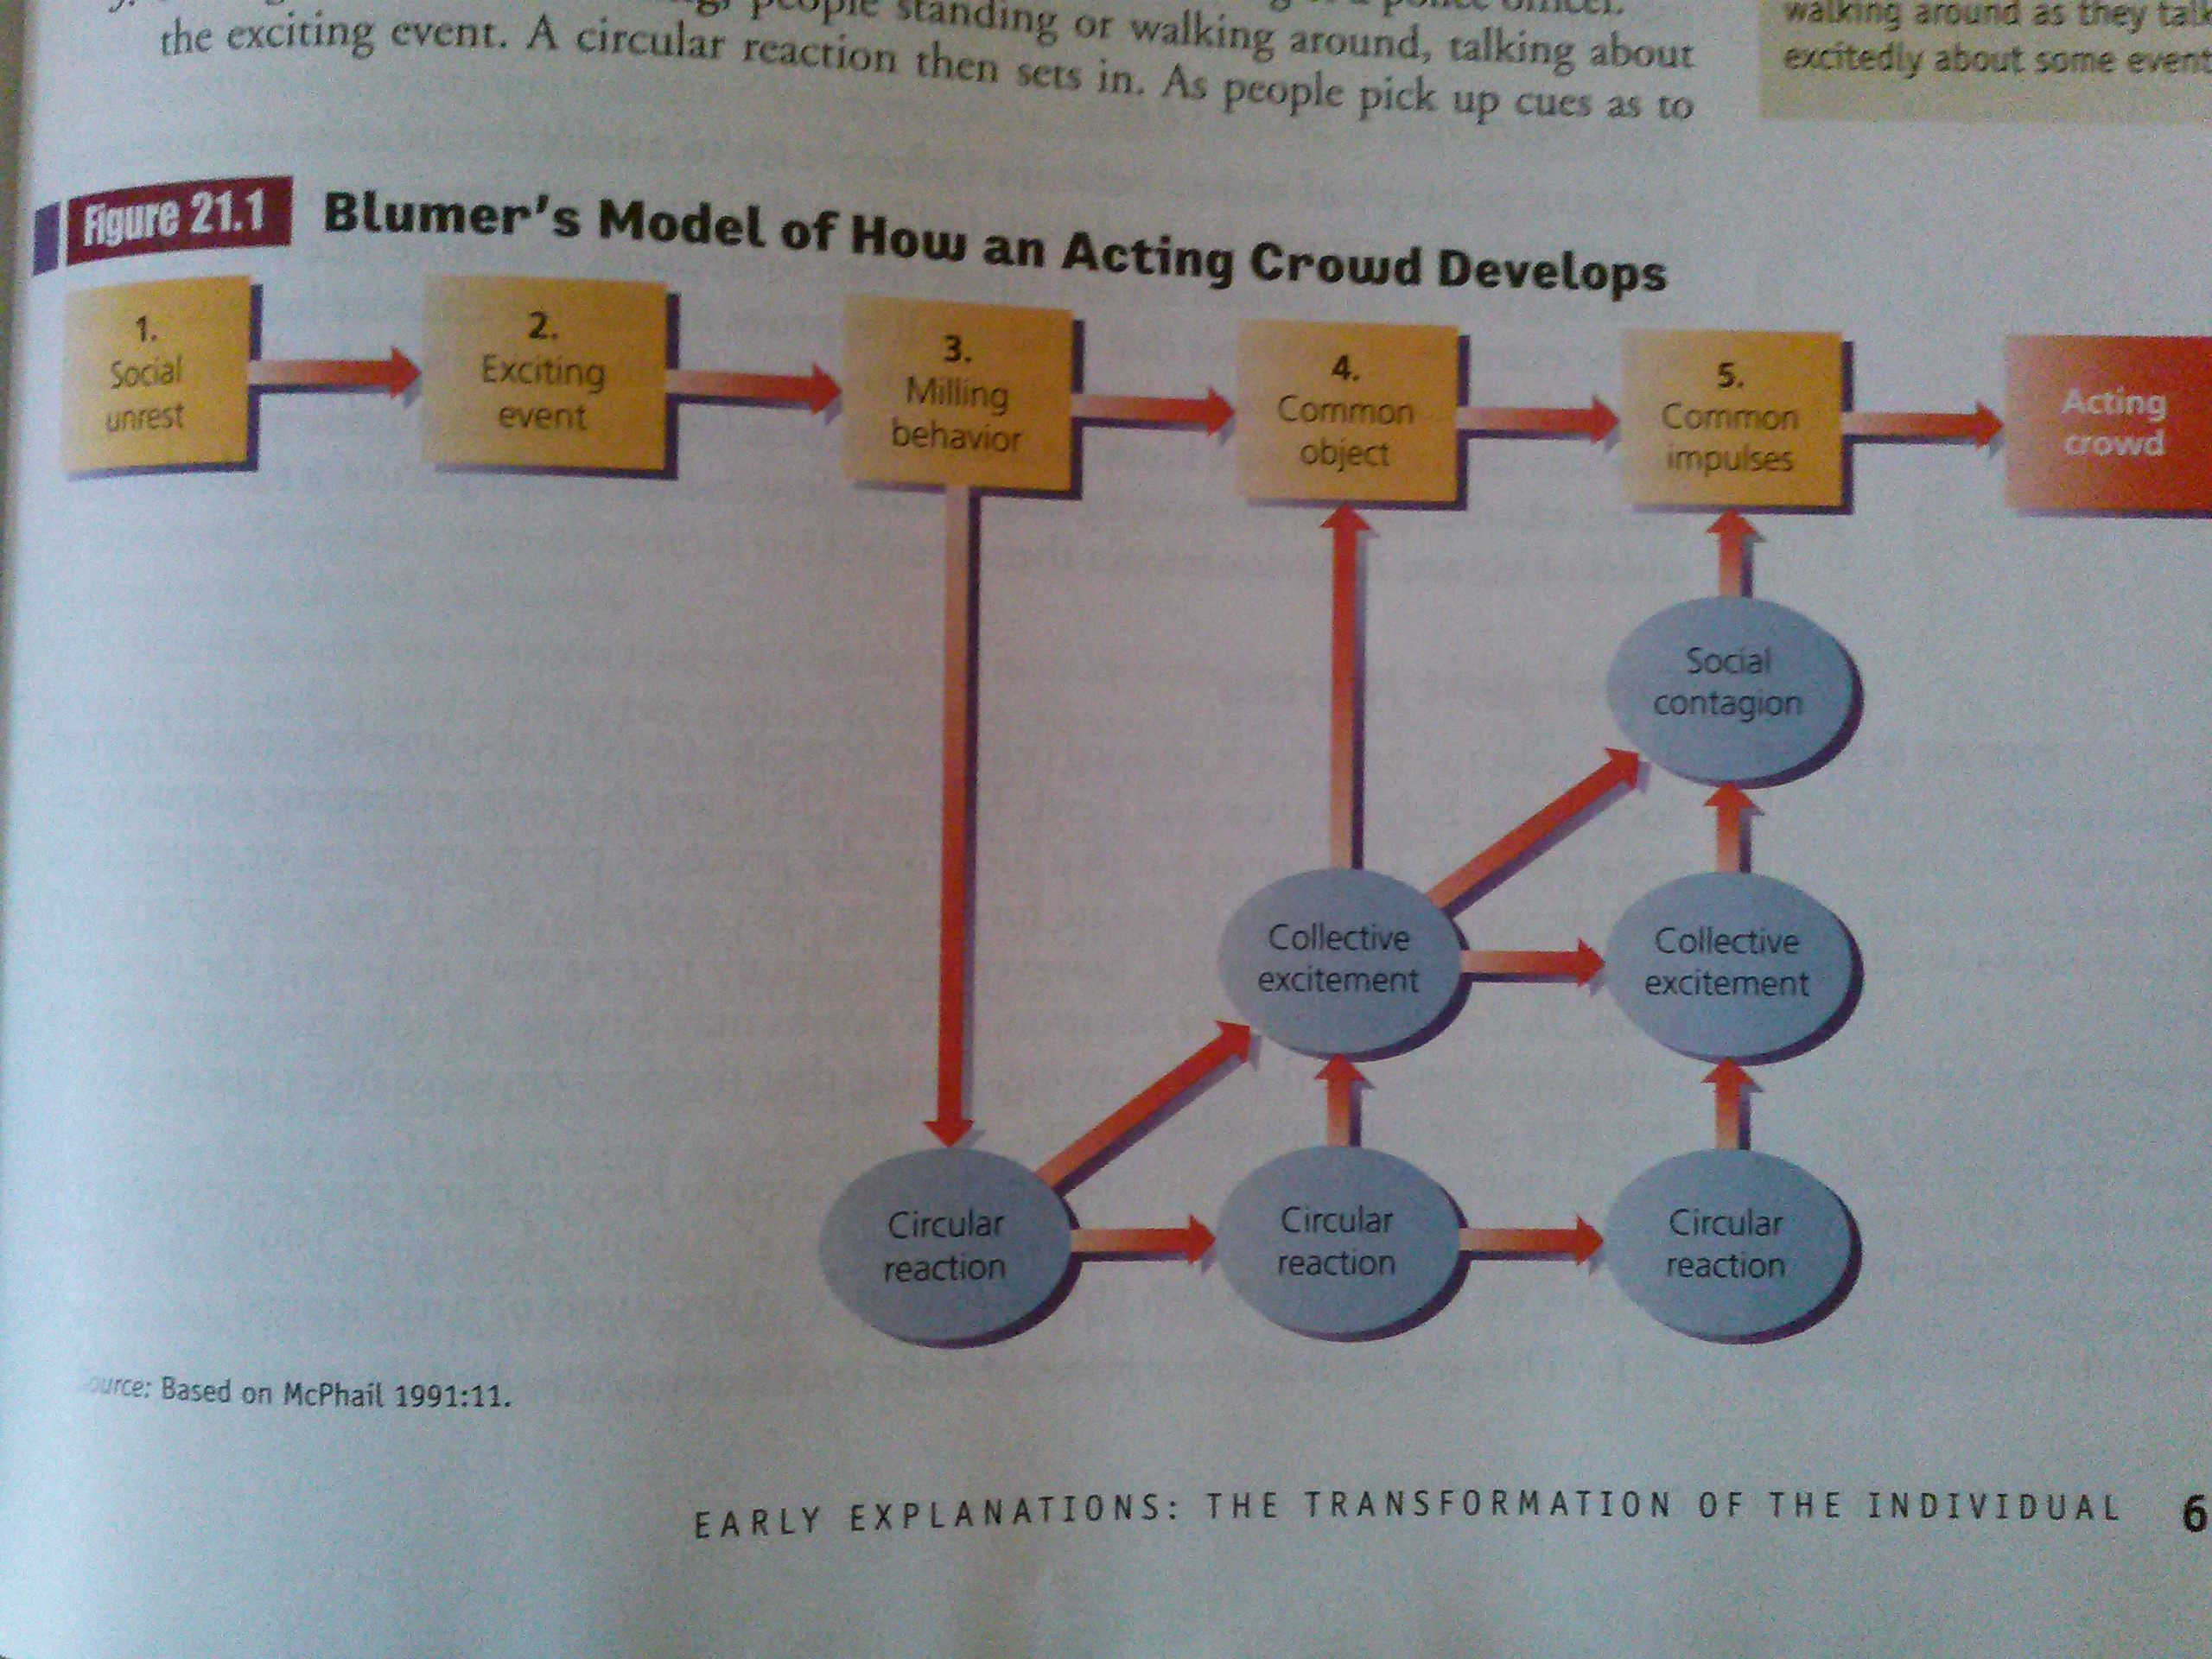
    - socail unrest
-pre-existing
    - exciting event
-an evewnt so startling that people become pre-occupied with it
    - milling behaviour
-people stand or walk around, talking about the exciting event
-people pick up cues to the "right" way about thinking/feeling about the event
    - common object
-people's attention is concentrated on one aspect of the event
    - common impulses
-people get the feeling that they are in agreement about a course of action

-acting crowds do not have to be destructive, violent, or serious, but they can be
-people work together in acting crowds

The Minimax Strategy
-people try to minimize costs and maximize rewards
-the larger cost to reward ratio, the more likely we are to do it
Emergent Norms
types of people in a crowd
    - the ego involved
-feel a personal stake in the unusual event
-participate/lead the crowd the most
    - the concerned
-have a personal interest in the event, but not as much as the ego involved
    - the insecure
-don't care very much about the issue
-join the crowd because it gives them a sense of power, security, or belonging
    - the curious spectators
-don't care very much about the issue
-currious about what is going on
    - the exploiters
-don't care about the issue at all
-use the event for personal gain
-unlikely to participate, but give passive support

Riots
background conditions
-frustration
-anger
-feeling of deprevation
-precipitating event
-is the "match" that ignites pre-existing tension and anger
-opportunists also participate in riots
-people who see a riot as an exciting event and an opportunity for looting

Rumors
-fill in missing information
-short lived (normally)
-arise in a situation of ambiguity
-dissipate when replaced with factual information or another rumor
-usually passed directly from one person to another, although occationally they are passed through media

main factors
-important to an individual
-replace ambiguity with certainty
-attributed to a credible source (like a person)

Panic (Mass Hysteria)
-people are so fearful that they cannot function normally
-many people flee the situation they perceive as threatening
-can be set off by rumors
-for panic, a predisposition of fear and uncertainy is in place before a frightful event
-not everyone panics, especially people with primary bonds (parents help their children)
-people with high empathy help others in times of panic

Moral Panics
-occur when large numbers of people become concerned and fearful about some behavior that they believe threatens morality
-even when the fear is exagerated and there is no connection to actual danger
-the threat is percieved as enormous
-hostitlity builds towards those deemed responsible
-fueled by mass media or rumors
-center around a sense of danger
-thrive on uncertainty and anxiety

Urban Legends
-stories that sound realistic and have a moral lesson
-false
-usually told by people who believed that it happened
-spread by rumors
-details make them more appealing

Social Movements
-when large numbers of people organize to promote or resist socail change
-memebers homd strong ideas about what is wrong with the world (or some part of it) and how to make things right
-fueled by a sense of injustice
-people develope socail movement organizations to gather support
-also to gather support they use attention-getting devices
-marches
-protest rallies
-sit-ins
-boycotts
-etc.
-socail movements fuel more socail movements
-socail movements are more likely to happen if many people's needs are unfulfilled (by societies institutions

Tactics of Socail Movements
-levels of membership
    - the inner core
-most commited
-sets groups goals, scheduals, and strategies
    - the committed
-somewhat less commited than the inner core
-counted on to show up for demonstrations
-counted on for grunt work
-help with mailings
-pass out petitions/leaflets
-make telephone calls
    - the less committed
-less commited
-less dependable
-participation depends on convenience
    - sympathetic public
    - hostile public
    - indifferent and unaware public
The Stages of Social Movements
- Initial unrest and agitation
-people upset about something and want to change it
-leaders emerge who verbalize people's feelings
- Resouce mobilization
-gathering resources
-time
-money
-information
-attention from the media
- Organization
-devision of labor is set up
-leadership makes decisions needed to keep the movement going
- Insitutionalization
-the movement has developped buerocracy
-the initial excitement deminishes
- Orgaizational decline and possible resurgence
-managing the day-to-day needs of the organizations is the main leadership task
-the movement is likely to die away (not in all cases)
-leaders may reamerge at any point and re-inspire the movement

Formal Organizations and Bureaucracies

The Characteristics of Bureaucracies
- Clear levels, with assignments floawing downward and accountability flowing upward
- A division of labor
- Written rules
- Written communications and records
- Impersonality and replaceability

On the Characteristics of Total Institutions by Erving Goffman

characteristics of total institutions (cults, prisons, mental institutions)

- All aspects of life are conducted in the same place and under the same central authority
- Everyone does everything at exactly the same time and in exactly the same way
- Strict schedueling enforced by formal rules and a body of officials
- All of the activities are brought together into a single rational plan to fulfill the official aims of the institution

